The general formula of alcohol is
A. $ROH$
B. $RCH_{2}OH$
C. $C_{6}H_{5}OH$
D. $ROR$
ANSWER: A
The general formula of phenol is
A. $ROH$
B. $RCH_{2}OH$
C. $C_{6}H_{5}OH$
D. $ROR$
ANSWER: C

Which of the following bonds is not reactive, when alcohol reacts with other reagents?
A. C-O
B. O-H
C. C-C
D. None of these
ANSWER: C
Phenol is also known as
A. Derivative of benzene
B. Aromatic alcohol
C. Carbolic acid
D. All of these
ANSWER: D
Which of the following difference in alcohol and phenol is related to the structure?
A. Phenolate ions have resonance structures while alcohols do not
B. Alcohols have bumming taste while phenols have phenolic odour
C. Phenols are more acidic than alcohols
D. All of these
ANSWER: A
Which of the following is known as hydroquinone?
A. 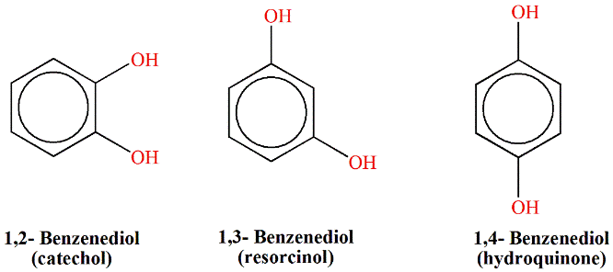
B. 
C. 
D. All of these
ANSWER: C
Which statement is correct about the acidic behavior of phenol?
A. It readily dissolve in alkalis
B. It is too weak to affect litmus paper
C. It is too weak to evolve $CO_{2}$
D. All of these
ANSWER: D

Disassociation constant value of phenol is:
A. $1.5×{10}^{-10}$
B. $1.7×{10}^{-5}$
C. $1.3×{10}^{-10}$
D. $1.8×{10}^{-3}$
ANSWER: C

Which of the following is known as catechol?
A. 
B. 
C. 
D. All of these
ANSWER: A

Phenols are more acidic than _________.
A. Ethanol
B. Formic acid
C. Ethanoic acid
D. Propanoic acid
ANSWER: A

Which of the following is known as resorcinol?
A. 
B. 
C. 
D. All of these
ANSWER: B
Acidic nature of phenol is due to:
A. Hydroxyl group
B. Aromatic ring
C. Phenoxide
D. Double bond
ANSWER: C

Which of the following order of acidic strength is correct?
A. Phenol > carboxylic acid > water > alcohol
B. Carboxylic acid > phenol > water > alcohol
C. Alcohol > Phenol > carboxylic acid > water
D. Water > alcohol > phenol > carboxylic acid
ANSWER: B
Which of the following reaction proves acidic nature of phenol?
A. Phenol reacts with acetyl chloride
B. Phenol reacts with caustic soda
C. Phenol reacts with Zinc
D. All of these
ANSWER: B

General formula of monohydric alcohol is:
A. $C_{n}H_{2n-1}OH$
B. $C_{n}H_{2n+1}2OH$
C. $C_{n}H_{2n+1}OH$
D. $C_{n}H_{2n}OH$
ANSWER: C

